GUIDELINES FOR USING THE REFERENCE PRICE DATABASE SYSTEM (PRDB) BY SUBJECTS
- Use of PRDB
  - Identification
To use the Reference Price Database System (PRDB) the user logs into the site https://prdb.azhbr.gov.al
The following image is displayed to the user, click on the icon
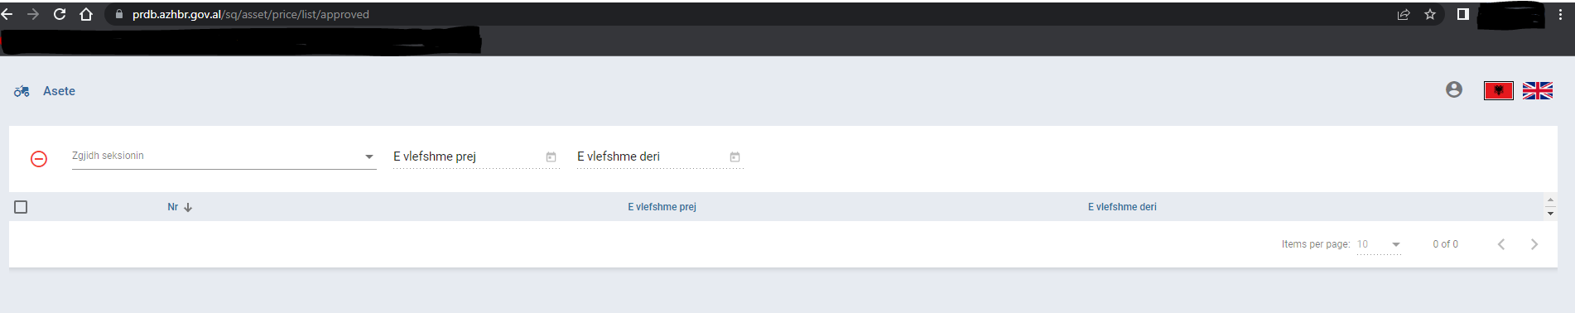
The "Log in" icon appears and is clicked
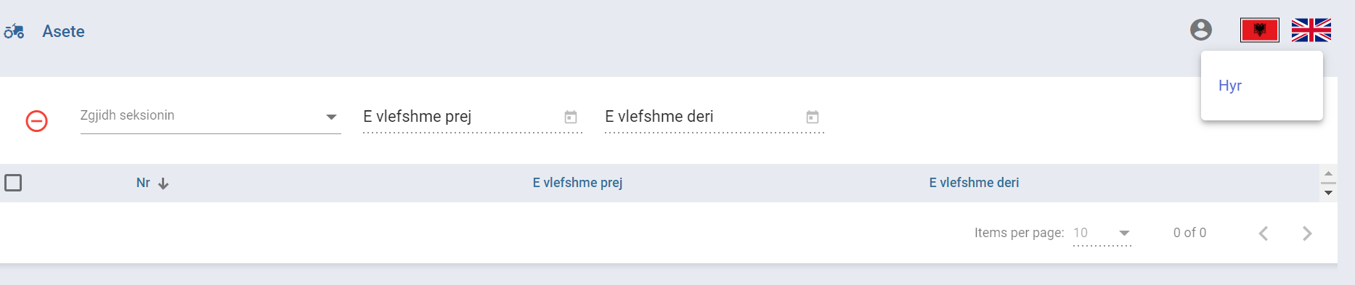
The user is identified by completing the credentials (e-mail, password) which he creates himself.
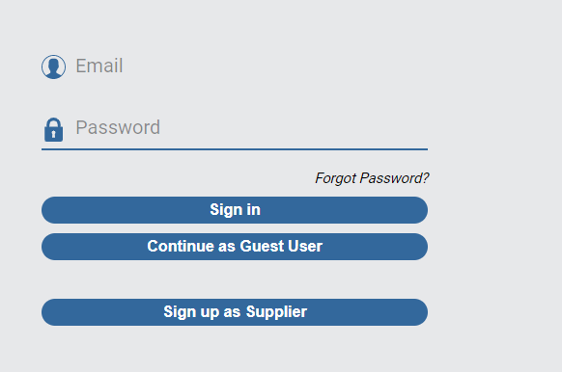
  - Register as a supplier (entity)
The user can register as a supplier by filling in the following fields: Name, Identification Code (Vat Number), type of supplier, section where it operates, e-mail and password, as well as attach the necessary documents.
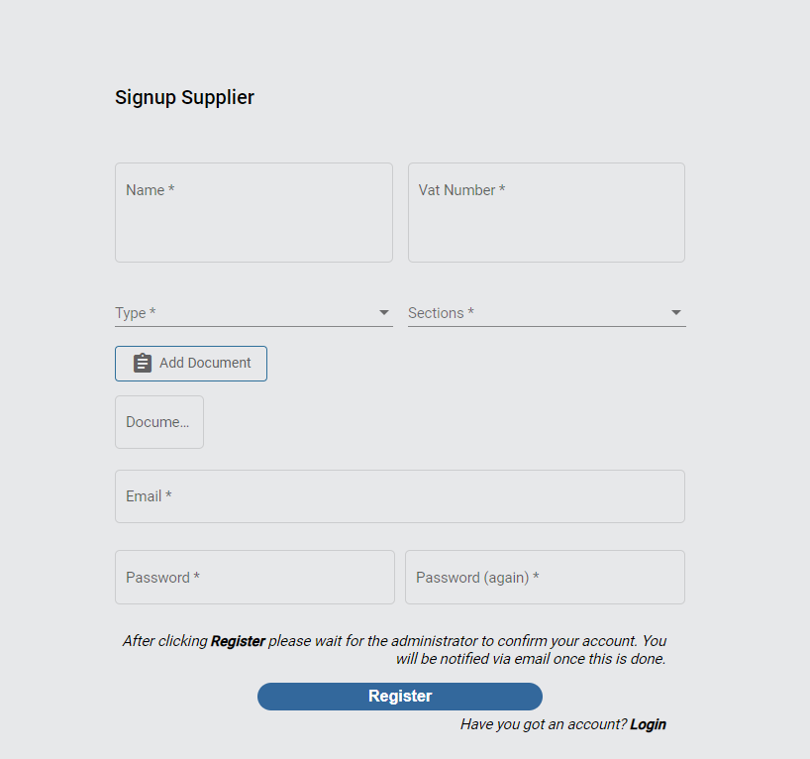

All fields marked with (*) are required.
After completing the above fields, the user must wait for a confirmation sent by the administrator (ARDA), after verifying the documents by the responsible persons, their account has become active.

